- BFS search:
Not optimal because the algorithm explores outside of the world since there’s a leak in the borders.
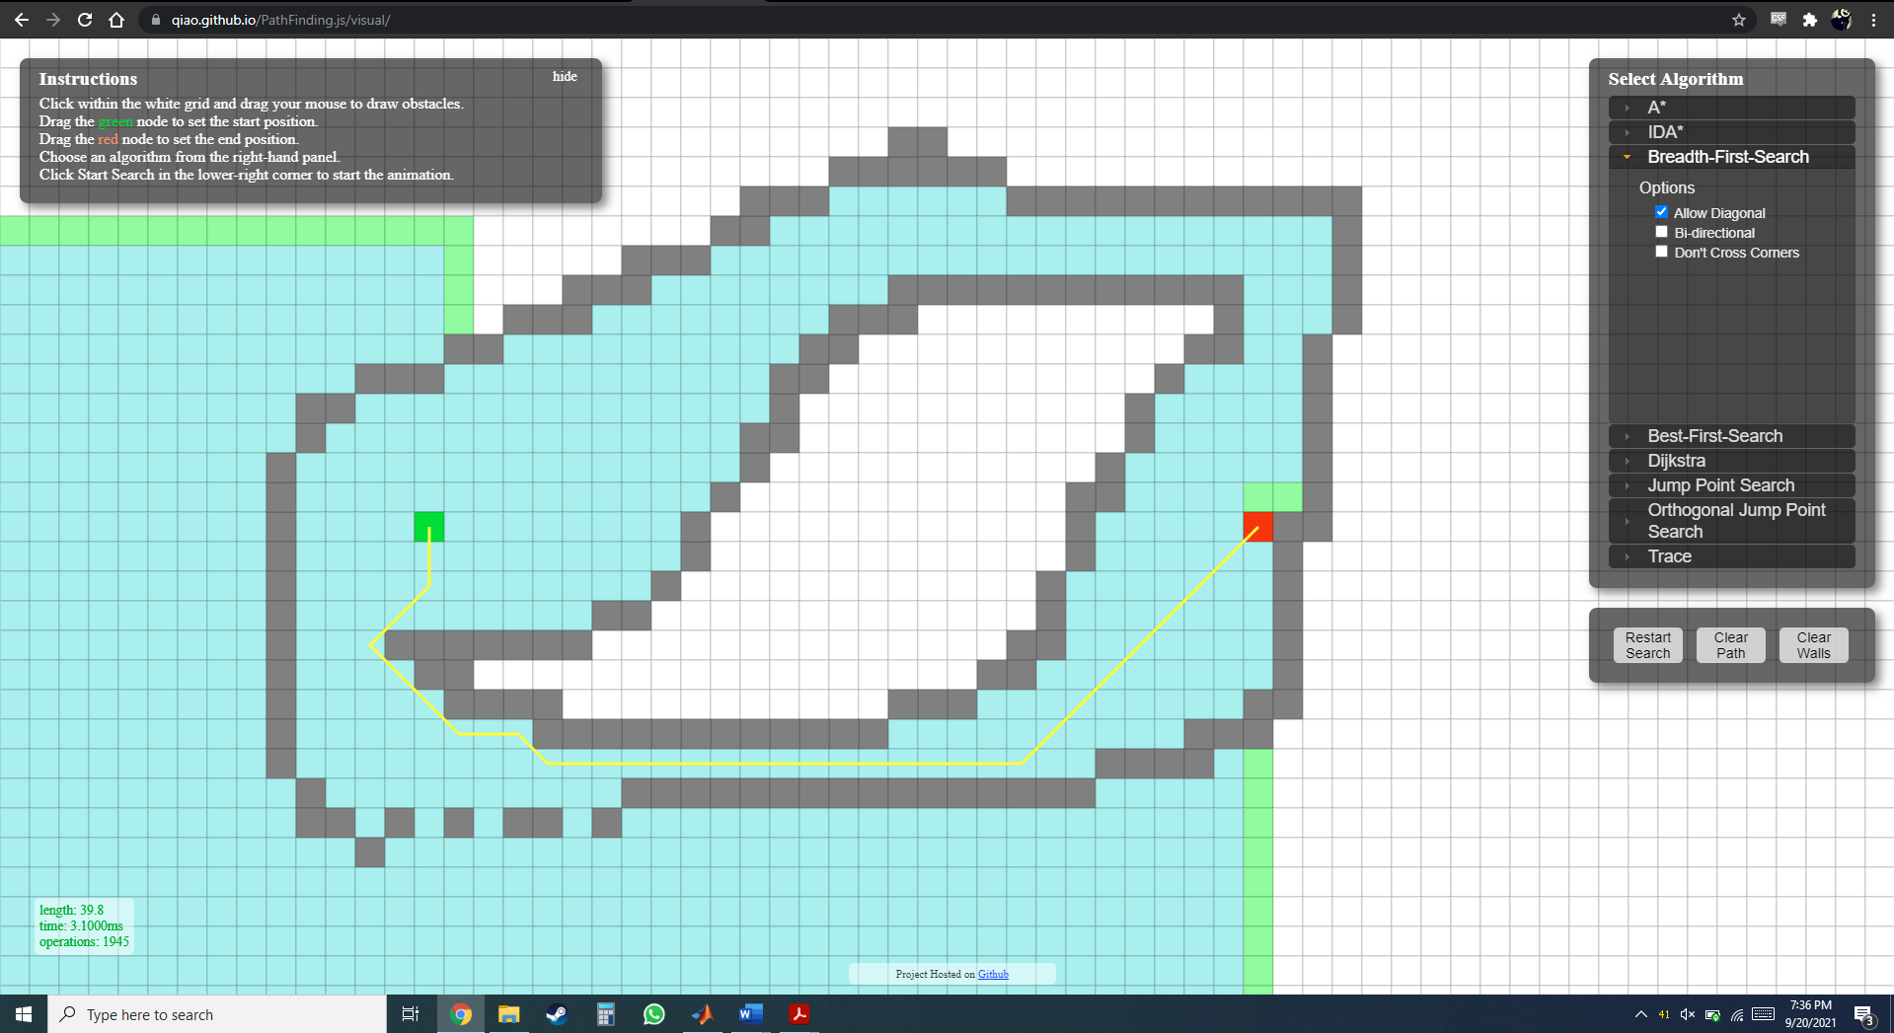
- This will be best solved by DFS because there are only a limited number of branches to expand on where the solution is reached and hence DFS will reach the solution quicker. Instead of going ahead with a 360 scan, DFS will expand on the branches having the solution first unless it’s the worst case and the solution branch is the last to expand.
